**DATA ANALYSIS USING PYTHON**

**LAB BOOK**

DEEPIKA V

18BBTCS029

**IF-ELSE:**

1. **OBJECTIVE :**  To find whether the number is even or not.

**Code:**

num = int(input("enter the number?"))

if num%2 == 0:

    print("Number is even")

print("bye")

**OUTPUT:**

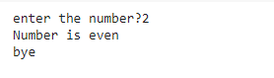

1. **Objective:** To find largest among three numbers

**Code:**

a = int(input("Enter a- "))

b = int(input("Enter b- "))

c = int(input("Enter c- "))

if a>b and a>c:

         print("a is largest")

if b>a and b>c:

       print("b is largest")

if c>a and c>b:

        print("c is largest")

**OUTPUT:**

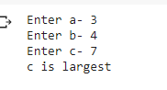

1. **Objective:** To check if one is eligible to vote or not.

**Code**:

age = int (input("Enter your age? "))

if age>=18:

    print("You are eligible to vote !!")

else:

  print("Sorry! you have to wait !!")

**OUTPUT**:



1. **Objective:** To check whether the number is even or odd

**Code:**

num = int (input("enter the number?"))

if num%2 == 0:

      print("Number is even...")

else:

      print("Number is odd...")

**OUTPUT:**



1. **OBJECTIVE**: Program to check if the entered number is equal to 10,50,100 or no.

**Code**:

number = int (input("Enter the number?"))

if number==10:

    print("number is equals to 10")

elif number==50:

    print("number is equal to 50")

elif number==100:

    print("number is equal to 100")

else:

    print("number is not equal to 10, 50 or 100")

**OUTPUT**:

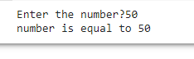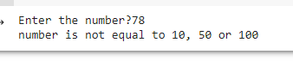

1. **Objective:**  Program to check the marks scored using if, elif

**Code**:

marks = int(input("Enter the marks? "))

if marks > 85 and marks <= 100:

    print("Congrats ! you scored grade A ...")

elif marks > 60 and marks <= 85:

   print("You scored grade B + ...")

elif marks > 40 and marks <= 60:

    print("You scored grade B ...")

elif (marks > 30 and marks <= 40):

     print("You scored grade C ...")

else:

    print("Sorry you are failed!")

**OUTPUT**:

## 

## 

## STRINGS:

1. **Code:**

### var1 = 'Hello World!'

var2 = "Python Programming" print(var1," ",var2)

**output:**

Hello World! Python Programming

1. **Code:**

### var1 = 'Hello World!'

var2 = "Python Programming"

print (var1[0]) print (var2[1:5])

**output:**

H

ytho

1. **Code:**

### var1 = 'Hello World!'

print ("Updated String :- ", var1[0:6] + 'Deepika')

**output:**

Updated String :- Hello Deepika

**4.Code:**

### str1 = input("Please Enter Your Own String : ")

str2 = str1 str3 = str1[:] str4 = str1[2:6]

print("The Final String : Str2 = ", str2) print("The Final String : Str3 = = ", str3) print("The Final String : Str4 = = ", str4)

**output:**

Please Enter Your Own String : hello class The Final String : Str2 = hello class The Final String : Str3 = = hello class The Final String : Str4 = = llo

1. **Code:**

### #Python String capitalize() method returns a copy of the string with on ly its first character capitalized.

str = "this is string example. wow!!!";

print ("str.capitalize() : ", str.capitalize())

**output:**

str.capitalize() : This is string example. wow!!!

1. **Code:**

### #center() returns centered in a string of length width. Padding is done using the specified fillchar. Default filler is a space.

str = "this is string example. wow!!!"

print ("str.center(40, 'a') : ", str.center(40, '*'))

**output:**

str.center(40, 'a') : ****this is string example. wow!!!****

1. **Code:**

### #count() returns the number of occurrences of substring sub in the rang e [start, end].

#str.count(sub, start= 0,end=len(string)) str = "this is string example. wow!!!";

sub = "i";

print ("str.count(sub, 4, 40) : ", str.count(sub, 4, 40)) sub = "wow";

print ("str.count(sub) : ", str.count(sub))

**output:**

str.count(sub, 4, 40) : 2

str.count(sub) : 1

**8.Code:**

### #isalnum() checks whether the string consists of alphanumeric character s.

str = "this2009"; # No space in this string print (str.isalnum())

str = "this is string example. wow!!!";

print (str.isalnum())

**output:**

True False

**9.Code:**

### str = "Deepika"; # No space & digit in this string print (str.isalpha())

str = "this is string example. wow!!!";

print (str.isalpha())

**output:**

True False

**10.Code:**

### str = "123456"; # Only digit in this string print (str.isdigit())

str = "this is string example. wow!!!";

print (str.isdigit())

**output:**

True False

**11.Code:**

### str = "THIS is string example. wow!!!";

print (str.islower())

str = "this is string example. wow!!!";

print (str.islower())

**output:**

False True

1. **Code:**

### str = "this2009"; print (str.isnumeric())

str = "23443434";

print (str.isnumeric())

**output:**

False True

**13.Code:**

### str = " ";

print (str.isspace())

str = "This is string example. wow!!!";

print (str.isspace())

**output:**

True False

**14.Code:**

### str = "This Is String Example...Wow!!!"; print (str.istitle())

str = "This is string example. wow!!!";

print (str.istitle())

**ouput:**

True False

**15.Code:**

### str = "THIS IS STRING EXAMPLE. WOW!!!";

print (str.isupper())

str = "THIS is string example. wow!!!";

print (str.isupper())

**output:**

True False

**16.Code:**

### str = "this is string example. wow!!!";

print ("Length of the string: ", len(str))

**output:**

Length of the string: 32

**17.Code:**

### #lstrip() returns a copy of the string in which all chars have been str ipped from the beginning of the string (default whitespace characters)

str = " this is string example....wow!!! "; print (str.lstrip())

str = "88888888this is string example. wow!!!999999";

print (str.lstrip('8'))

print (str.rstrip('9'))

**output:**

this is string example. wow!!!

this is string example. wow!!!999999

88888888this is string example. wow!!!

**18.Code:**

### str = "THIS IS STRING EXAMPLE. WOW!!!";

print (str.lower())

**output:**

this is string example. wow!!!

**19.Code:**

### #returns largest character str = "check. wow!!!";

print ("Max character: " + max(str))

str = "shabnam. !!!";

print ("Max character: " + max(str))

**output:**

Max character: w Max character: s

**20.Code:**

### str = "this is string example. wow!!!";

print (str.startswith( 'this' )) print (str.startswith( 'is', 2, 4 ))

print (str.startswith( 'this', 2, 4 ))

**output:**

True True False

**21.Code:**

### str = "this is string example. wow!!!";

print ("str.capitalize() : ", str.upper())

**ouput:**

str.capitalize() : THIS IS STRING EXAMPLE. WOW!!!

**22.Code:**

### str = "this is string example. wow!!!";

print (str.swapcase())

str = "THIS IS STRING EXAMPLE. WOW!!!";

print (str.swapcase())

**output**:

THIS IS STRING EXAMPLE. WOW!!!

this is string example. wow!!!

**Dictionaries:**

**Code:**

dict={'name':'Deepika','designation':'Student','qual':'Btech','univ':'cmr'}

print(dict['name'])

print(dict['qual'])

**output:**

Deepika

Btech

**Code:**

dict={'name':'anu','designation':'student','qual':'student','univ':'cmr'}

dict['name']='deepika'

print(dict['name'])

dict['class']='cse7sem'

print(dict['class'])

**output:**

deepika

cse7sem

**Code:**

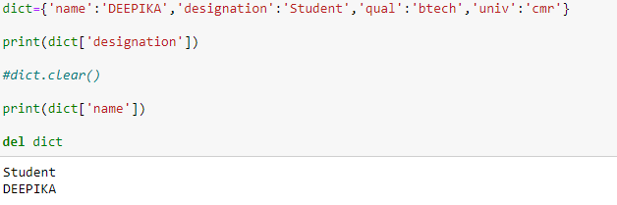

**Code:**

dict = {

"name": "Anu",

"designation": "Student",

"qual": "btech",

"year": 2021,

"name": "Rinku",

}

print(dict['name'])

print(len(dict))

**OUTPUT:**

Rinku

4

**Code:**

dict={'name':'Anu','designation':'student','qual':'btech','univ':'cmr', 'name':'Deepika'}

print(dict.values())

print(dict.items())

print(dict.keys())

OUTPUT:

dict_values(['Deepika', 'student', 'btech', 'cmr'])

dict_items([('name', 'Deepika'), ('designation', 'student'), ('qual', 'btech'), ('univ', 'cmr')])

dict_keys(['name', 'designation', 'qual', 'univ'])

**Code:**

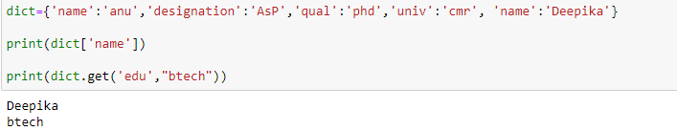

**Code:**

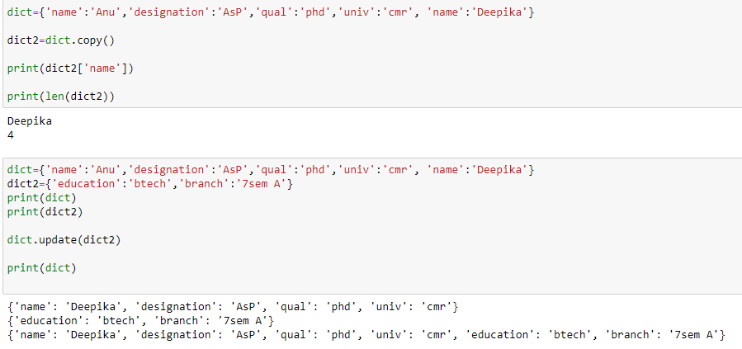

**TUPLES:**

**Code:**

tup= ('cse','it','mech')

print(tup)

tup1=(1,23,4,5,5,6)

print(tup1)

tup2="abc","def"

print(tup2)

**OUTPUT:**

('cse', 'it', 'mech')

(1, 23, 4, 5, 5, 6)

('abc', 'def')

**Code:**

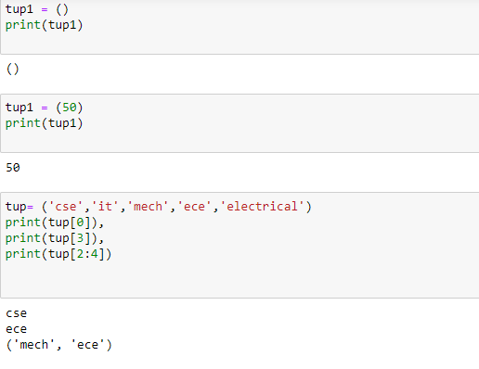

**Code:**

tup1= ('cse','it','mech','ece','electrical')

print(tup1)

tup2= ('deepika','anshu','hema','shak')

print(tup2)

tup3=tup1+tup2

print(tup3)

**output:**

('cse', 'it', 'mech', 'ece', 'electrical')

('deepika', 'anshu', 'hema', 'shak')

('cse', 'it', 'mech', 'ece', 'electrical', 'deepika', 'anshu', 'hema', 'shak')

**Code:**

tup1= ('cse','it','mech','ece','electrical')

print(tup1)

print("value at 3rd loc= ",tup1[4])

tup1[4]="civil" #not allowed

print("UPDATED value at 3rd loc= ",tup1[4])

**output:**

('cse', 'it', 'mech', 'ece', 'electrical')

value at 3rd loc= electrical

**Code:**

tup1= ('cse','it','mech','civil','ece','electrical')

print(tup1)

tup2= ('deepika','nishitha','anu')

print(tup2)

a=len(tup1)

b=len(tup2)

print(a)

print(b)

print(len(tup1))

**output:**

('cse', 'it', 'mech', 'civil', 'ece', 'electrical')

('deepika', 'nishitha', 'anu')

6

3

6

**Code:**

tup1= ('cse','it','mech','civil','ece','electrical')

print(tup1)

tup2= ('deepika','anshu','hema')

print(tup2)

print(max(tup1))

output:

('cse', 'it', 'mech', 'civil', 'ece', 'electrical')

('deepika', 'anshu', 'hema')

mech

# LISTS:

**Code:**

### list1 = ['physics', 'chemistry', 1997, 2000];

list2 = [1, 2, 3, 4, 5, 6, 7 ];

print ("list1[0]: ", list1[2])

print ("list2[1:5]: ", list2[1:3])

**output:**

list1[0]: 1997

list2[1:5]: [2, 3]

**Code:**

### list = ['physics', 'chemistry', 1997, 2000]; print ("Value available at index 2 : ") print (list[2])

list[2] = 999999;

print ("New value available at index 2 : ") print (list[2])

**output:**

Value available at index 2 : 1997

New value available at index 2 : 999999

**Code:**

### list1 = ['physics', 'chemistry', 1997, 2000]; print (list1)

del (list1[2]);

print ("After deleting value at index 2 :") print (list1)

**output:**

['physics', 'chemistry', 1997, 2000] After deleting value at index 2 : ['physics', 'chemistry', 2000]

**Code:**

### list1, list2 = [123, 'xyz', 'zara'], [456, 'abc'] print ("First list length : ", len(list1))

print ("Second list length : ", len(list2))

**output:**

First list length : 3 Second list length : 2

**Code:**

### aList = [123, 'xyz', 'zara', 'abc']; aList.append( 2009 );

print ("Updated List : ", aList)

**output:**

Updated List : [123, 'xyz', 'zara', 'abc', 2009]

**Code:**

### aList = [123, 'xyz', 'xyz', 'abc', 123]; print ("Count for xyz : ", aList.count('xyz'))

print ("Count for zara : ", aList.count('zara'))

**output:**

Count for xyz : 2 Count for zara : 0

**Code:**

### aList = [123, 'xyz', 'zara', 'abc', 123]; bList = [2009, 'shabnam']; aList.extend(bList)

print ("Extended List : ", aList)

**output:**

Extended List : [123, 'xyz', 'zara', 'abc', 123, 2009, 'shabnam']

**Code:**

print ("Index for xyz : ", aList.index( 'xyz' ) ) print ("Index for zara : ", aList.index( 'zara' ) )

**output:**

Index for xyz : 1 Index for zara : 2

**Code:**

### aList = [123, 'xyz', 'zara', 'abc'] aList.insert( 3, 2009)

print ("Final List : ", aList)

**output:**

Final List : [123, 'xyz', 'zara', 2009, 'abc']

**Code:**

### aList = [123, 'xyz', 'zara', 'abc']; print(aList)

print ("List after popping last element : ", aList.pop()) print(aList)

print ("List after popping element from mentioned index: ", aList.pop(2

))

print(aList)

aList.insert(3, 2009) print(aList)

**output:**

[123, 'xyz', 'zara', 'abc']

List after popping last element : abc [123, 'xyz', 'zara']

List after popping element from mentioned index: zara [123, 'xyz']

[123, 'xyz', 2009]

**Code:**

### aList = [123, 'xyz', 'zara', 'abc', 'xyz']; aList.remove('xyz');

print ("List : ", aList) aList.remove('abc'); print ("List : ", aList)

**output:**

List : [123, 'zara', 'abc', 'xyz']

List : [123, 'zara', 'xyz']

**Code:**

### aList = ['naveen', 'shabnam', 'sonia', 'ali', 'nive']; aList.sort();

print ("List : ", aList)

**output:**

List : ['ali', 'naveen', 'nive', 'shabnam', 'sonia']

**LOOPS:**

**Objective: Basic loop functions.**

**Code:**

### str = "Python" for i in str:

print(i)

**output:**

P

y t h o n

**Objective**: Basic loop functions to print tables.

**Code:**

### list = [1,2,3,4,5,6,7,8,9,10]

n = 6

for i in list: c = n*i

print(n," *",i, " =", c)

**output:**

|  |  |
| --- | --- |
| 6 | * 1 = 6 |
| 6 | * 2 = 12 |
| 6 | * 3 = 18 |
| 6 | * 4 = 24 |
| 6 | * 5 = 30 |
| 6 | * 6 = 36 |
| 6 | * 7 = 42 |
| 6 | * 8 = 48 |
| 6 | * 9 = 54 |
| 6 | * 10 = 60 |

**Objective**: Basic loop functions to print sum of numbers.

**Code:**

list = [10,30,23,43,65,12]

sum = 0

for i in list: sum = sum+i

print("The sum is:",sum)

**output:**

The sum is: 183

**Objective**: Basic loop functions to print range of numbers.

**Code:**

### for i in range(14):

print(i,end=' ')

**output:**

0 1 2 3 4 5 6 7 8 9 10 11 12 13

**Code:**

### n = int(input("Enter the number ")) for i in range(1,11):

c = n*i print(n,"*",i,"=",c)

**output:**

Enter the number 4

|  |  |  |  |  |
| --- | --- | --- | --- | --- |
| 4 | * | 1 | = | 4 |
| 4 | * | 2 | = | 8 |
| 4 | * | 3 | = | 12 |
| 4 | * | 4 | = | 16 |
| 4 | * | 5 | = | 20 |
| 4 | * | 6 | = | 24 |
| 4 | * | 7 | = | 28 |
| 4 | * | 8 | = | 32 |
| 4 | * | 9 | = | 36 |

4 * 10 = 40

**Code:**

### n = int(input("Enter the number ")) for i in range(2,n,2):

print(i)

output:

Enter the number 19 2

4

6

8

10

12

14

16

18

**Code:**

### list = ['Peter','Shabnam','Ricky','Devansh'] for i in range(len(list)):

print("Hello",list[i])

**output:**

Hello Peter Hello Shabnam Hello Ricky Hello Devansh

**Code:**

### for i in range(0,7):

print(i) print("bye") continue; print("hello")

else:print("for loop is exhausted");

print("The loop is broken due to break statement...came out of the loop")

**output:**

0

bye 1

bye 2

bye 3

bye 4

bye 5

bye 6

bye

for loop is exhausted

The loop is broken due to break statement...came out of the loop

**Code:**

### # prints all letters except 'a' and 't' i = 0

str1 = 'shabnam' print(str1)

while i < len(str1):

print('entered while loop before if statement') if str1[i] == 'a' or str1[i] == 'u':

print('entered if statement') i += 1

print('i incremented') continue

print('after continue')

print('Current Letter :', str1[i]) i += 1

print('going back to starting of while loop')

**output:**

shabnam

entered while loop before if statement Current Letter : s

going back to starting of while loop entered while loop before if statement Current Letter : h

going back to starting of while loop entered while loop before if statement entered if statement

i incremented

entered while loop before if statement Current Letter : b

going back to starting of while loop entered while loop before if statement Current Letter : n

going back to starting of while loop entered while loop before if statement entered if statement

i incremented

entered while loop before if statement Current Letter : m

going back to starting of while loop

**code:**

### i = 0

str1 = 'shabnam'

while i < len(str1): if str1[i] == 'n':

i += 1

break

print('Current Letter :', str1[i]) i += 1

output:

Current Letter : s Current Letter : h Current Letter : a Current Letter : b Current Letter : a Current Letter : m

**code:**

### #The pass statement is used to declare the empty loop.

#It is also used to define empty class, function, and control statement

.

str1 = 'deepika' i = 0

while i < len(str1):

i += 1

pass

print('Value of i :', i)

output:

Value of i : 7

**code:**

### i=1

#The while loop will iterate until condition becomes false. while(i<=10):

print(i) i=i+1

1

2

3

4

5

6

7

8

9

10

**code:**

### i=1

number = int(input("Enter the number:")) while i<=10:

print("%d X %d = %d \n"%(number,i,number*i)) i = i+1

Enter the number:3

|  |  |  |  |  |
| --- | --- | --- | --- | --- |
| 3 | X | 1 | = | 3 |
| 3 | X | 2 | = | 6 |
| 3 | X | 3 | = | 9 |
| 3 | X | 4 | = | 12 |
| 3 | X | 5 | = | 15 |
| 3 | X | 6 | = | 18 |
| 3 | X | 7 | = | 21 |
| 3 | X | 8 | = | 24 |
| 3 | X | 9 | = | 27 |

3 X 10 = 30

**code:**

while (1):

print("Hi! we are inside the infinite while loop")

output:

Hi! we are inside the infinite while loop Hi! we are inside the infinite while loop Hi! we are inside the infinite while loop Hi! we are inside the infinite while loop Hi! we are inside the infinite while loop Hi! we are inside the infinite while loop Hi! we are inside the infinite while loop Hi! we are inside the infinite while loop Hi! we are inside the infinite while loop Hi! we are inside the infinite while loop Hi! we are inside the infinite while loop Hi! we are inside the infinite while loop Hi! we are inside the infinite while loop Hi! we are inside the infinite while loop Hi! we are inside the infinite while loop Hi! we are inside the infinite while loop Hi! we are inside the infinite while loop Hi! we are inside the infinite while loop Hi! we are inside the infinite while loop Hi! we are inside the infinite while loop Hi! we are inside the infinite while loop Hi! we are inside the infinite while loop Hi! we are inside the infinite while loop Hi! we are inside the infinite while loop Hi! we are inside the infinite while loop Hi! we are inside the infinite while loop Hi! we are inside the infinite while loop Hi! we are inside the infinite while loop Hi! we are inside the infinite while loop Hi! we are inside the infinite while loop Hi! we are inside the infinite while loop Hi! we are inside the infinite while loop Hi! we are inside the infinite while loop Hi! we are inside the infinite while loop Hi! we are inside the infinite while loop Hi! we are inside the infinite while loop Hi! we are inside the infinite while loop Hi! we are inside the infinite while loop Hi! we are inside the infinite while loop Hi! we are inside the infinite while loop Hi! we are inside the infinite while loop Hi! we are inside the infinite while loop Hi! we are inside the infinite while loop Hi! we are inside the infinite while loop Hi! we are inside the infinite while loop Hi! we are inside the infinite while loop

**code:**

### var = 1

while(var != 2):

i = int(input("Enter the number:")) print("Entered value is %d"%(i))

output:

Enter the number:3 Entered value is 3 Enter the number:3 Entered value is 3 Enter the number:4 Entered value is 4 Enter the number:5 Entered value is 5 Enter the number:6 Entered value is 6 Enter the number:7 Entered value is 7 Enter the number:2 Entered value is 2

**Code:**

### i=1 while(i<=5):

print(i) i=i+1

else:

print("The while loop exhausted")

output:

1

2

3

4

5

The while loop exhausted

**Code:**

### i=1 while(i<=5):

print(i) i=i+1 if(i==3):

break

else:

print("The while loop exhausted") print("bye bye")

output:

1

2

bye bye

**code:**

### list =[1,2,3,4] i=1;

count = 1; for i in list:

if i == 4:

print("item matched") count = count + 1; break

print("found at",count,"location");

output:

item matched

found at 2 location

**code:**

### str = "python" for i in str:

if i == 'o': break

print(i);

**output:**

p y t h

**Code:**

n=2

while 1:

i=1;

while i<=10:

print("%d X %d = %d\n"%(n,i,n*i)); i = i+1;

choice = int(input("Do you want to continue printing the table, press 0 for no?"))

if choice == 0: break;

|  |  |  |  |  |
| --- | --- | --- | --- | --- |
|  | | | | n=n+1 |
| 2 | X | 1 | = | 2 |
| 2 | X | 2 | = | 4 |
| 2 | X | 3 | = | 6 |
| 2 | X | 4 | = | 8 |
| 2 | X | 5 | = | 10 |
| 2 | X | 6 | = | 12 |
| 2 | X | 7 | = | 14 |
| 2 | X | 8 | = | 16 |
| 2 | X | 9 | = | 18 |
| 2 X 10 = 20  Do you want to | | | | |
| 3 | X | 1 | = | 3 |
| 3 | X | 2 | = | 6 |
| 3 | X | 3 | = | 9 |
| 3 | X | 4 | = | 12 |
| 3 | X | 5 | = | 15 |
| 3 | X | 6 | = | 18 |
| 3 | X | 7 | = | 21 |
| 3 | X | 8 | = | 24 |
| 3 | X | 9 | = | 27 |
| 3 | X | 10 = 30 | | |

;

continue printing the table, press 0 for no?1

**Code:**

### i = 0

while(i < 10): i = i+1 if(i == 5):

continue print(i)

**output:**

1

2

3

4

6

7

8

9

10

**code:**

### list = [1,2,3,4,5]

flag = 0

for i in list:

print("Current element:",i,end=" ");

if i==3:

pass

print("\nWe are inside pass block\n"); flag = 1

if flag==1:

print("\nCame out of pass\n");

flag=0

**output:**

Current element: 1 Current element: 2 Current element: 3 We are inside pass block

Came out of pass

Current element: 4 Current element: 5

**Code;**

### for i in [1,2,3,4,5]:

if(i==4):

pass

print("This is pass block",i) print(i)

**output:**

1

2

3

This is pass block 4 4

5

**Files:**

**Code:**

print("Python is really a great language,", "isn't it?")

**output:**

Python is really a great language, isn't it?

**Code:**

str = input("Enter your input: ")

print ("Received input is : ", str)

**output:**

Enter your input: HI HOW ARE YOU?

Received input is : HI HOW ARE YOU?

**Code:**

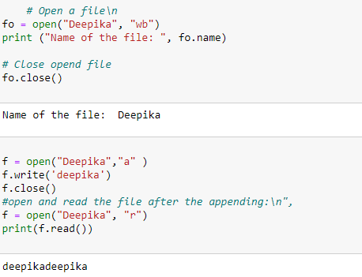

**Code:**

fo = open("Deepika.txt", "wb")

print ("Name of the file: ", fo.name)

print ("Closed or not : ", fo.closed)

print ("Opening mode : ", fo.mode)

**output:**

Name of the file: Deepika.txt

Closed or not : False

Opening mode : wb

**Programs on Numpy :**

1. **Code:**

import numpy as np

npa= np.array([1, 2, 3])

print(npa)

**output:**

[1 2 3]

1. **Code & output:**

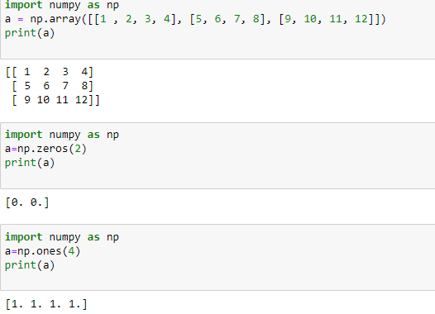

1. **Code:**

import numpy as np

ab=np.empty(4)

print(ab)

**output:**

[1. 1. 1. 1.]

1. **Code:**

import numpy as np

a=np.arange(7)

print(a)

**output:**

[0 1 2 3 4 5 6]

1. **Code:**

import numpy as np

a=np.array(9)

print("Print A= ",a)

b=np.array([10,20,30])

print("Print B= ", b)

addition= np.add(a,b)

print("After Addition =", addition)

sub=np.subtract(b,a)

print("After Subtraction =",sub)

mul=np.multiply (a,b)

print("After Multiplcation =",mul)

div=np.divide (b,a)

print("After Division =",div)

div1=np.divide (b,5)

print("After Division =",div1)

**output:**

Print A= 9

Print B= [10 20 30]

After Addition = [19 29 39]

After Subtraction = [ 1 11 21]

After Multiplcation = [ 90 180 270]

After Division = [1.11111111 2.22222222 3.33333333]

After Division = [2. 4. 6.]

1. **Code &output:**

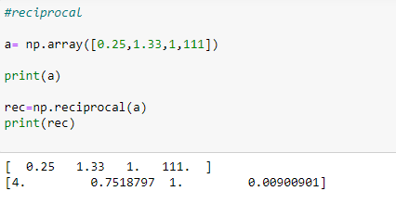

1. **Code:**

a=np.array([10,100,1000])

print(a)

pow=np.power(a,2)

print("after ^2 = ", pow)

b=np.array([2,3,1])

pow1=np.power(a,b)

print("after b array elements as ^ = ", pow1)

**output:**

[ 10 100 1000]

after ^2 = [ 100 10000 1000000]

after b array elements as ^ = [ 100 1000000 1000]

**Code:**

a= np.array ([10,20,30])

b= np.array ([3,5,7])

print("values of A=", a)

print("values of B=", b)

mm=np.mod(a,b)

rm=np.remainder(a,b)

print("values of MOD=", mm)

print("values of REMAINDER=", rm)

**output:**

values of A= [10 20 30]

values of B= [3 5 7]

values of MOD= [1 0 2]

values of REMAINDER= [1 0 2]

**Code & ouput:**

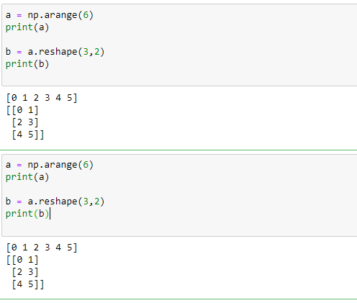

**Recharge Plan:**

#Recharge plan for service provider

print("Do you want to recharge ? Please enter Yes to proceed!")

typ=input()

print("Enter mobile number")

mob=int(input())

print("select operator - Enter 1 for Airtel\n2 for Vodafone\n3 for BSNL")

i=int(input())

if i==1:

    operator='Airtel'

    print("Enter 1 for Prepaid or 2 for Postpaid")

    num=int(input())

    if num==1:

        print("****Prepaid plans****")

        print("PLAN 1 - Rs.598 - 1.5GB/Day---84 Days validity")

        print("PLAN 2 - Rs.399 - 1.5GB/Day---56 Days validity")

        print("PLAN 3 - Rs.298 - 2GB/Day---28 Days validity")

        print("Enter your plan..")

        a=int(input())

        if a == 1:

            print("PLAN A1")

        elif a==2:

            print("PLAN 2")

        elif a==3:

            print("PLAN 3")

        print("Thank you for choosing us!\nYour plan will be activated within today!")

    if num==2:

        print("****Postpaid plans****")

        print("PLAN 1 - Rs.598 - 1.5GB/Day---84 Days validity")

        print("PLAN 2 - Rs.399 - 1.5GB/Day---56 Days validity")

        print("PLAN 3 - Rs.298 - 2GB/Day---28 Days validity")

        print("Enter your plan..")

        a= int(input())

        if a == 1:

            print("PLAN 1")

        elif a == 2:

            print("PLAN 2")

        elif a == 3:

            print("PLAN 3")

        print("Thank you for choosing us!\nYour plan will be activated within today!")

elif i==2:

    operator='Vodafone'

    print("Enter 1 for Prepaid or 2 for Postpaid")

    num=int(input())

    if num==1:

        print("****Prepaid plans****")

        print("PLAN 1 - Rs.598 - 1.5GB/Day---84 Days validity")

        print("PLAN 2 - Rs.399 - 1.5GB/Day---56 Days validity")

        print("PLAN 3 - Rs.298 - 2GB/Day---28 Days validity")

        print("Enter your plan..")

        a=int(input())

        if a==1:

            print("PLAN 1")

        elif a==2:

            print("PLAN 2")

        elif a==3:

            print("PLAN 3")

        print("Thank you for choosing us!\nYour plan will be activated within today!")

    if num==2:

        print("****Postpaid plans****")

        print("PLAN 1 - Rs.598 - 1.5GB/Day---84 Days validity")

        print("PLAN 2 - Rs.399 - 1.5GB/Day---56 Days validity")

        print("PLAN 3 - Rs.298 - 2GB/Day---28 Days validity")

        print("Enter your plan..")

        a=int(input())

        if a==1:

            print("PLAN 1")

        elif a==2:

            print("PLAN 2")

        elif a==3:

            print("PLAN 3")

        print("Thank you for choosing us!\nYour plan will be activated within today!")

elif i==3:

    operator='BSNL'

    print("Enter 1 for Prepaid or 2 for Postpaid")

    num=int(input())

    if num==1:

        print("****Prepaid plans****")

        print("PLAN 1 - Rs.598 - 1.5GB/Day---84 Days validity")

        print("PLAN 2 - Rs.399 - 1.5GB/Day---56 Days validity")

        print("PLAN 3 - Rs.298 - 2GB/Day---28 Days validity")

        print("Enter your plan..")

        a=input()

        if a==1:

            print("PLAN 1")

        elif a==2:

            print("PLAN 2")

        elif a==3:

            print("PLAN 3")

        print("Thank you for choosing us!\nYour plan will be activated within today!")

    if num==2:

        print("****Postpaid plans****")

        print("PLAN 1 - Rs.598 - 1.5GB/Day---84 Days validity")

        print("PLAN 2 - Rs.399 - 1.5GB/Day---56 Days validity")

        print("PLAN 3 - Rs.298 - 2GB/Day---28 Days validity")

        print("Enter your plan..")

        a=input()

        if a==1:

            print("PLAN 1")

        elif a==2:

            print("PLAN 2")

        elif a==3:

            print("PLAN 3")

        print("Thank you for choosing us!\nYour plan will be activated within today!")

print("Thank you for choosing us!")

**output:**

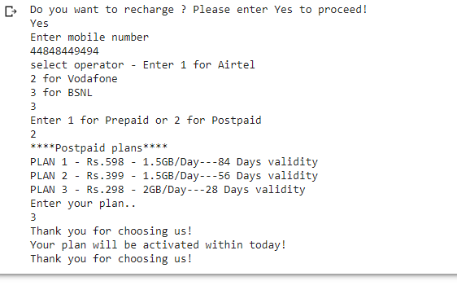

**Functions:**

1. **Program:**

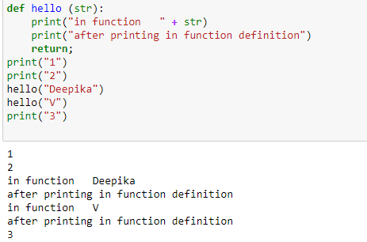

1. **Program:**

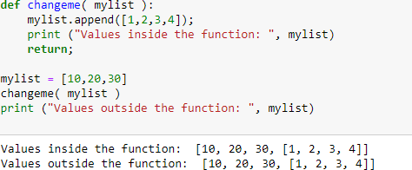

1. **Program:**
2. 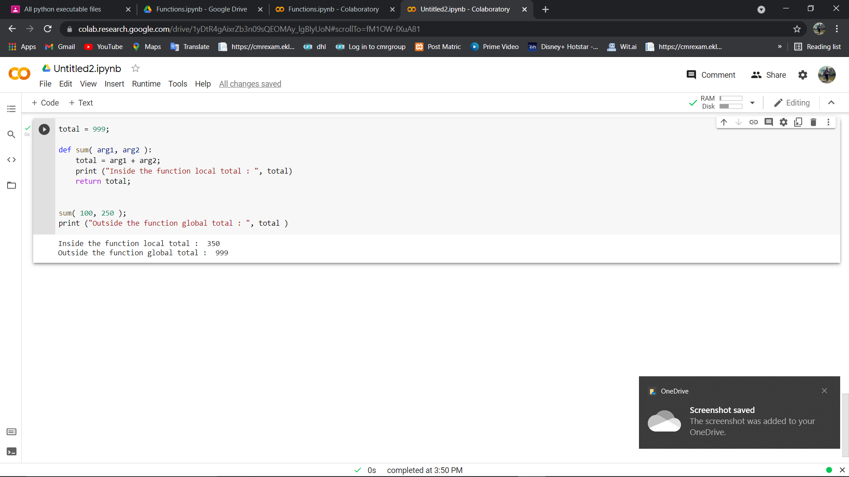**Program:**

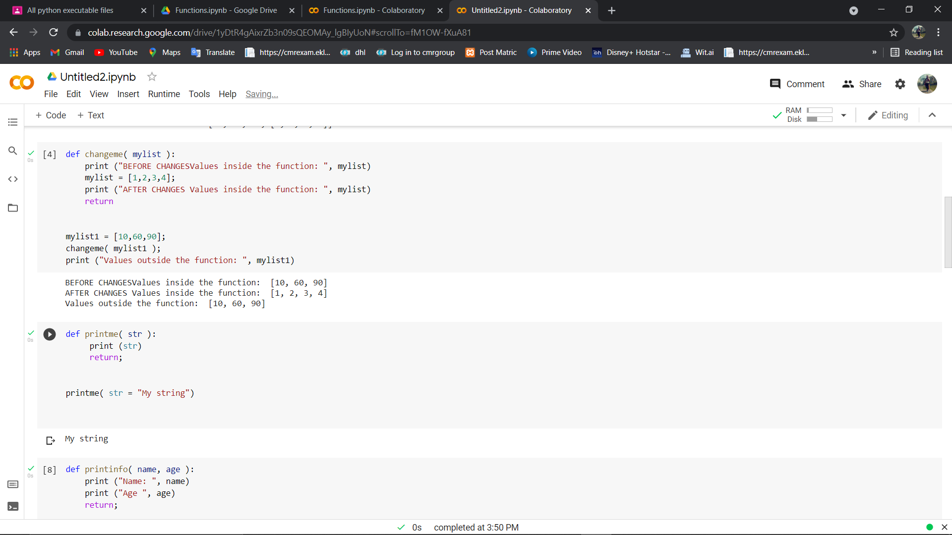

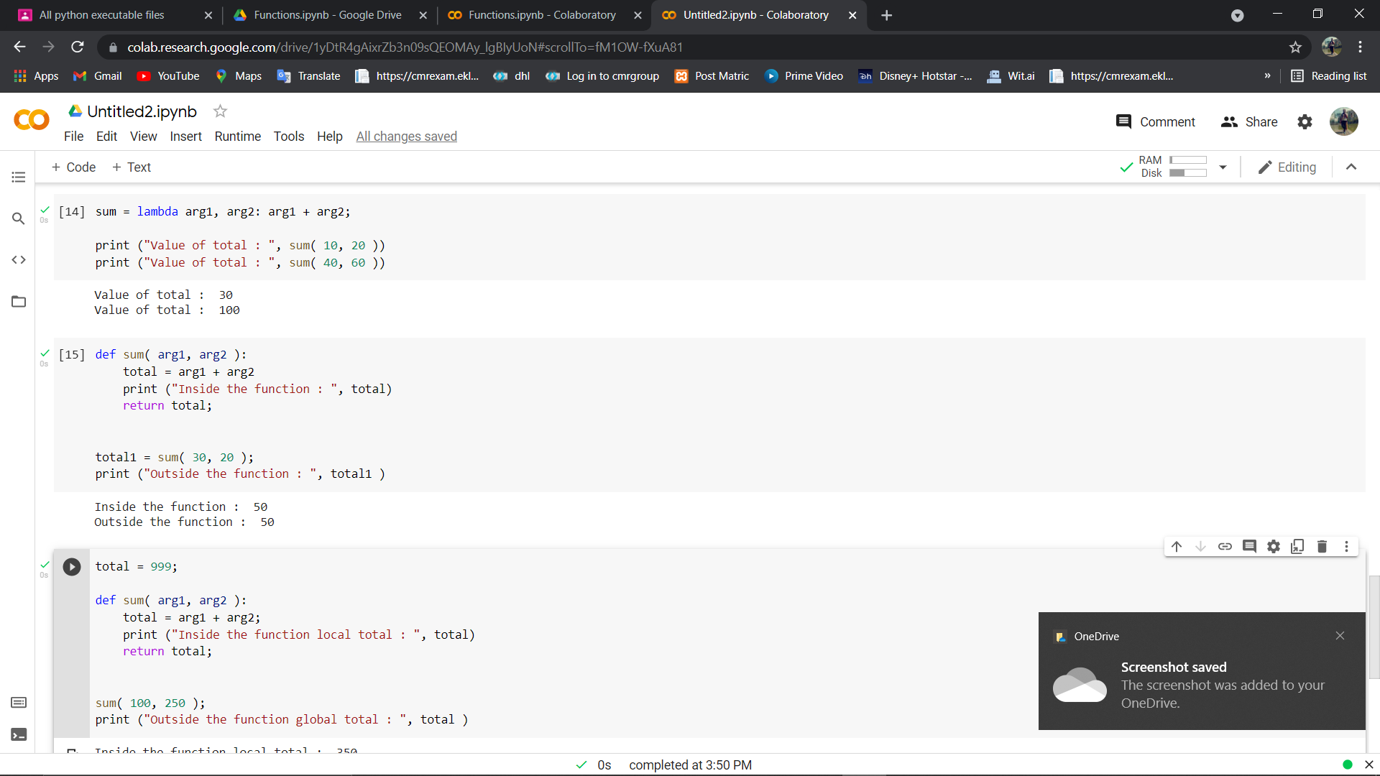

**Program on Restaurant order :**

**Program:**

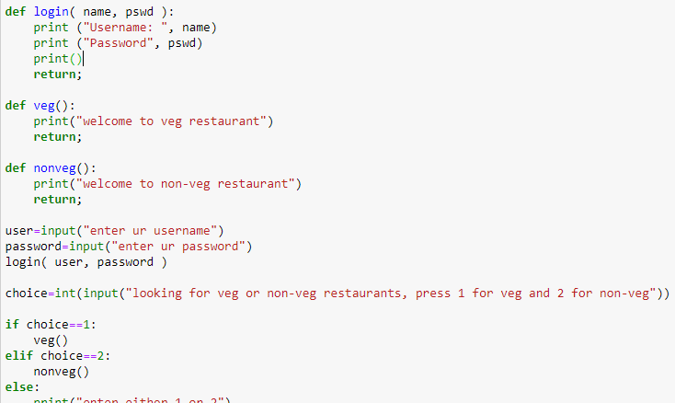

**Output:**

enter ur usernamedeepika

enter ur password1234

Username: deepika

Password 1234

looking for veg or non-veg restaurants, press 1 for veg and 2 for non-veg2

welcome to non-veg restaurant.